**Airline Data Management and Analysis Using Power BI**

**Objective:** To analyze and visualize airline data for operational insights, passenger management, and ticket booking trends using Power BI.

1. **Task 1:**

* Extract and transform data in Power Query.
* The datas do not contain any duplicate.But contain some unwanted null columns so I have deleted them.
* Here are the screenshots of clean data tables :

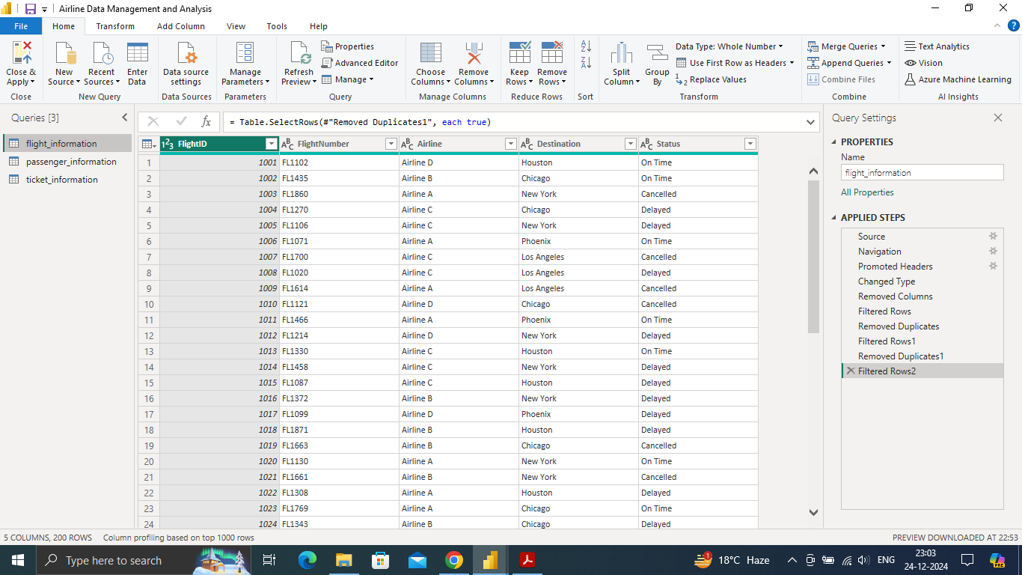

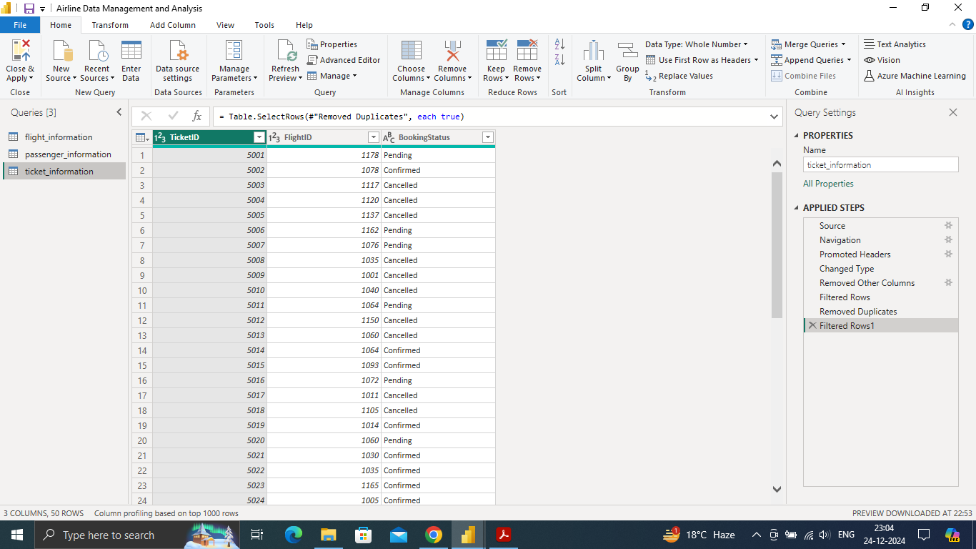

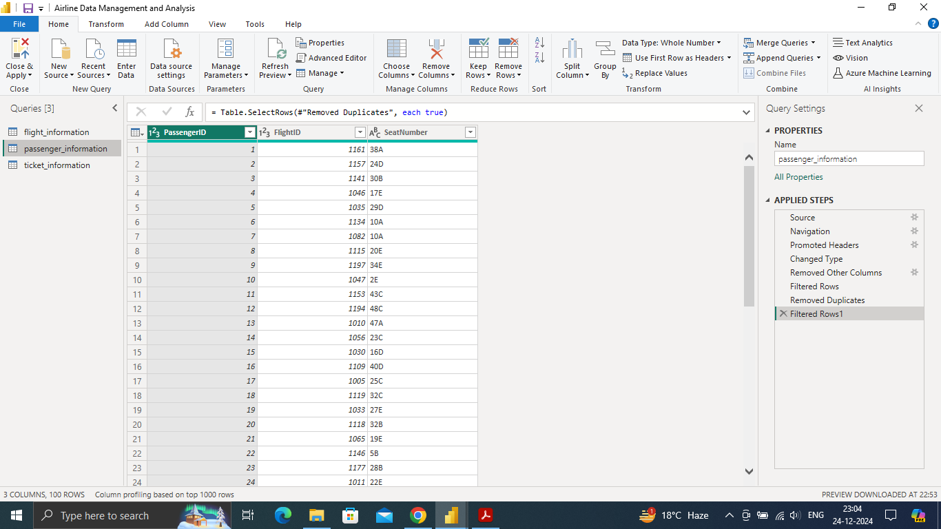

1. **Task 2 :**

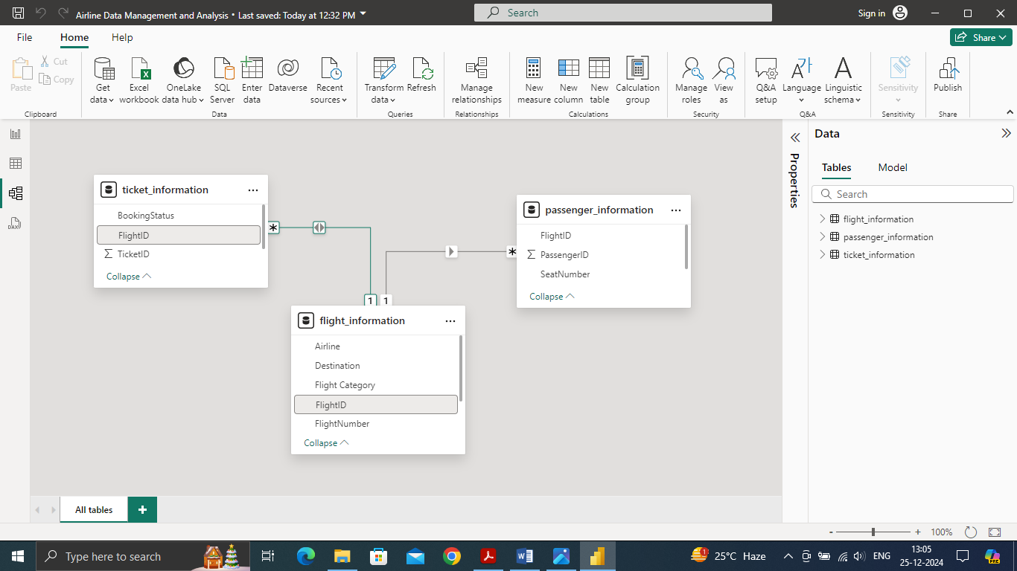

* *Created relationships between datasets (where FlightID is the key) in model view.*

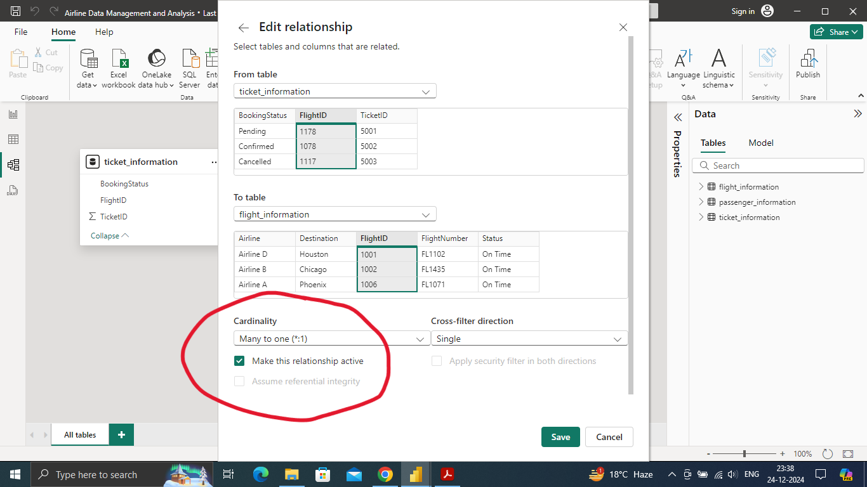

* *Edited the relationship ,here the cardinality is highlighted as you can see (Many to one).*

1. **Task 3 :**

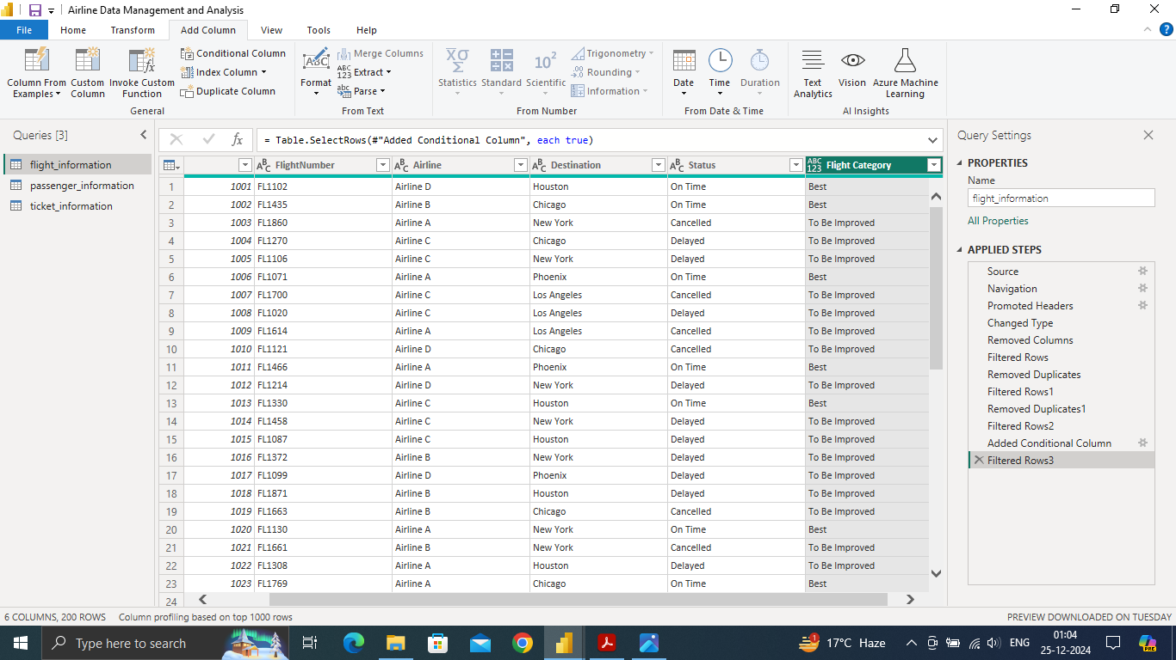

* *Added a conditional column (Flight Category) using Status. Where I configured ‘Best’ if the flight status is ‘On Time’ else ‘To Be Improved’*.

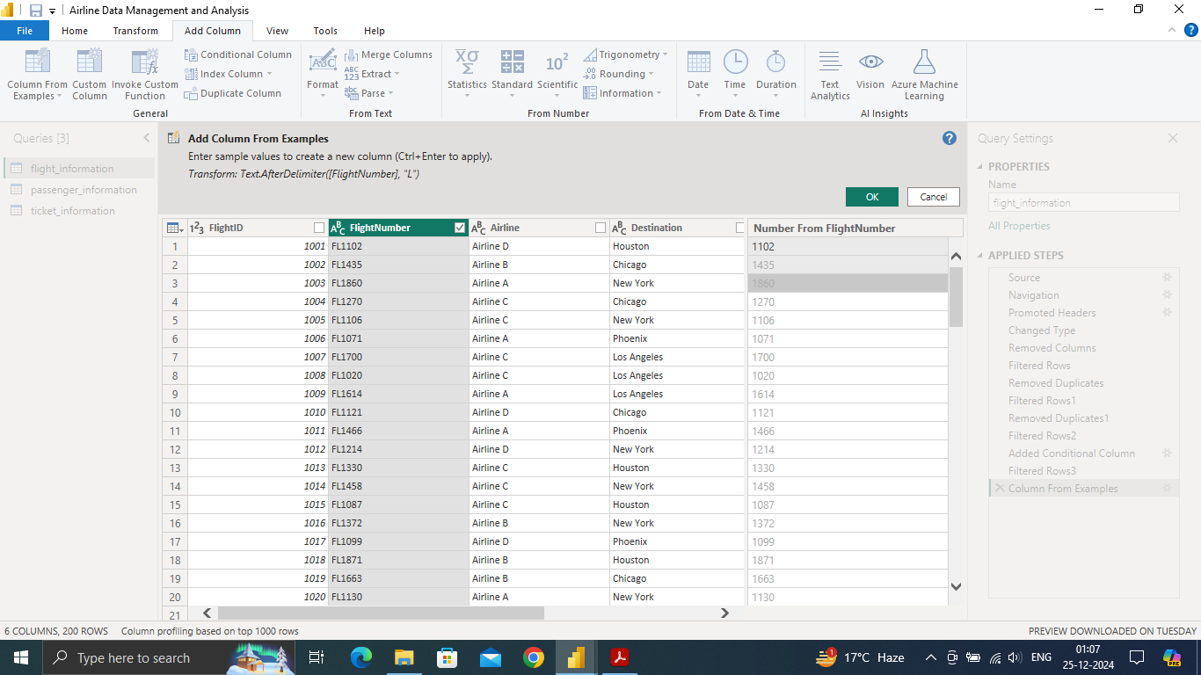

* *Added a column from example where I have extraxted only the number part from the ‘FlightNumber’ column in flight information table. Then change the format as whole number.*

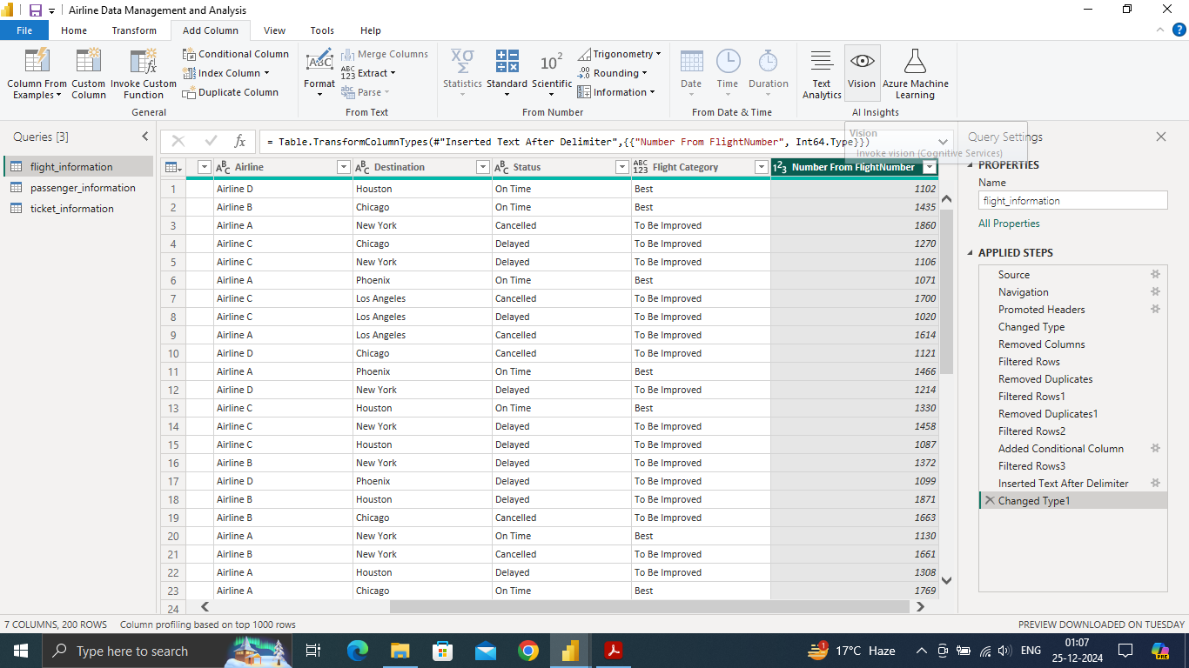

*Final outcome after extraction .*

1. **Task 4 :**



In task 4 basically I have created 2 dax measures.

1. Total Unique Passengers for FlightID “1085”

For that perpose I have created a dax formula that is : CALCULATE(DISTINCTCOUNT(passenger_information[PassengerID]),passenger_information[FlightID]= “1085”)

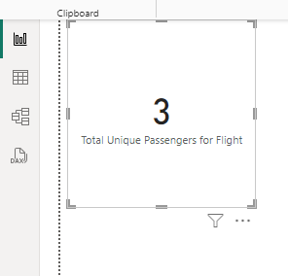

*I have also displayed the total passengers (that is 3) for FlightID “1085” in a card visual.*

1. Also created the total unqiue passengers calculation :

Total Passengers =DISTINCTCOUNT(passenger_information[PassengerID])

1. Again for total tickets booked another dax I have created that is

Total tickets booked = DISTINCTCOUNT(ticket_information[TicketID])

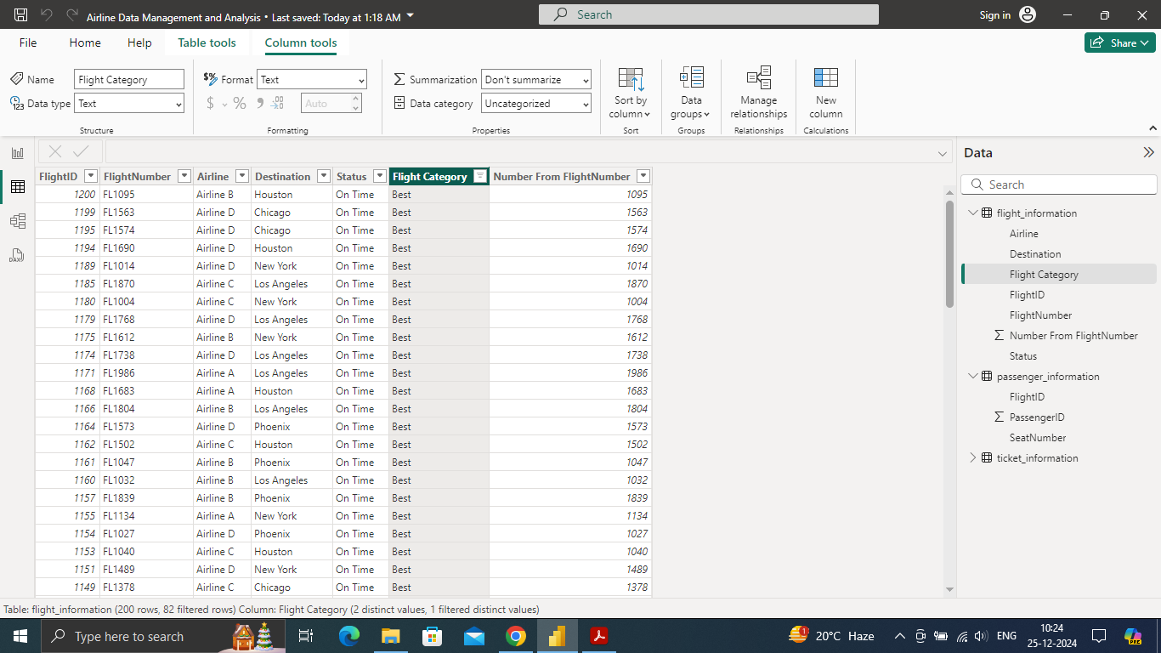

1. *Filtered the ‘Best’ Flight Category only in the table.*
2. **Task 5 (Reports) :**

**Visual 1:**

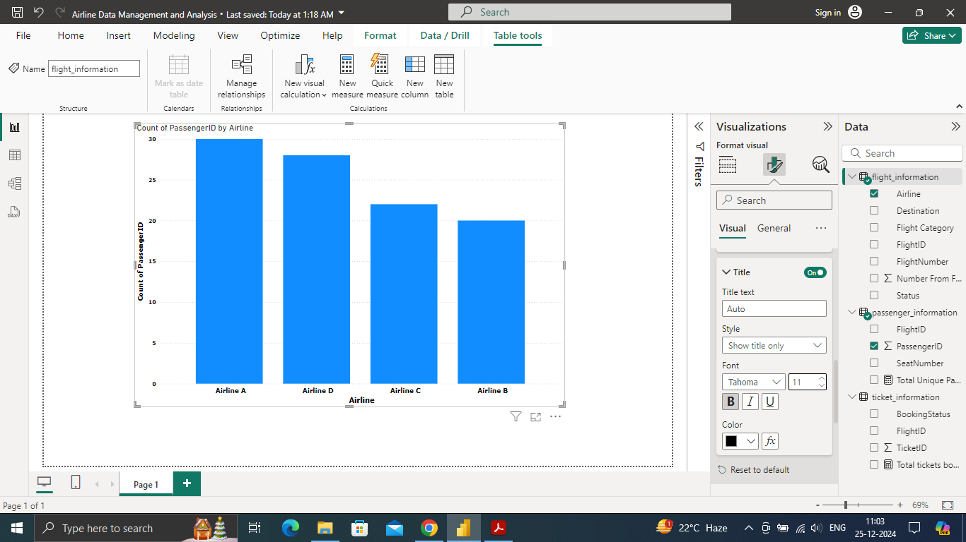

* *Passenger count by airline*

**Visual 2 :**

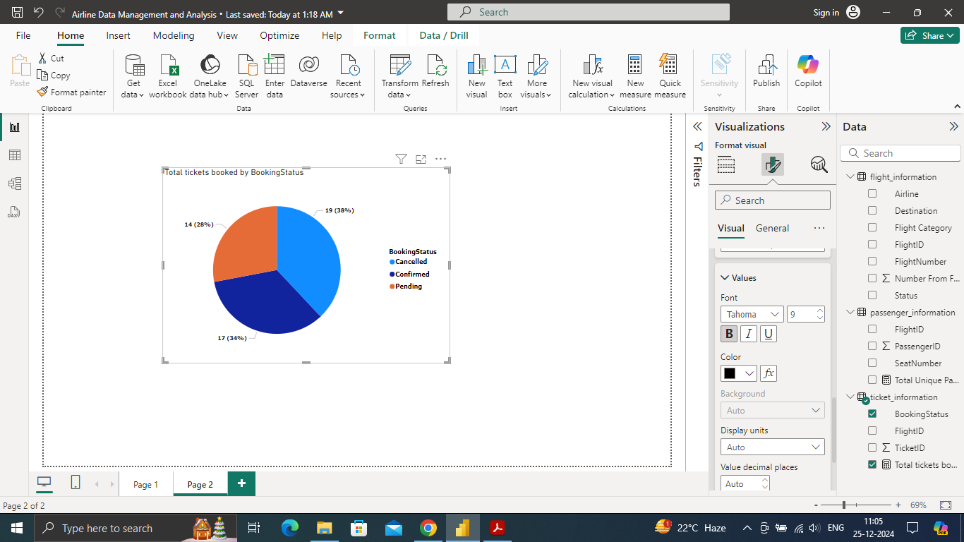

* *Ticket booking status ( a pie chart showing different percentage of booked tickets and their status)*

**Visual 3 :**

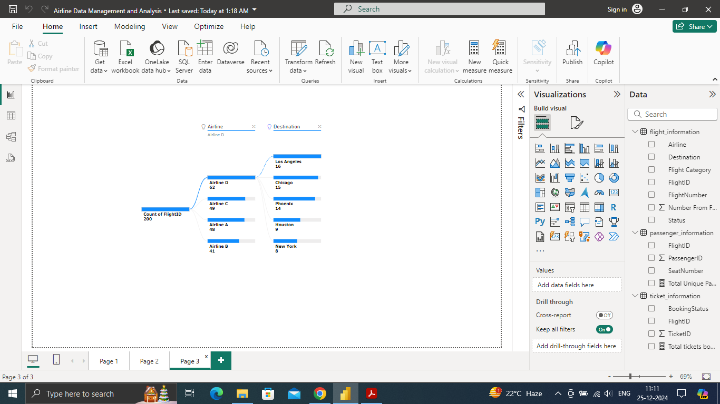

* *Flights by airline and destination* ( a dicompostion tree visual showing different flights across different Airline and different Destinations)

**Visual 4 :**

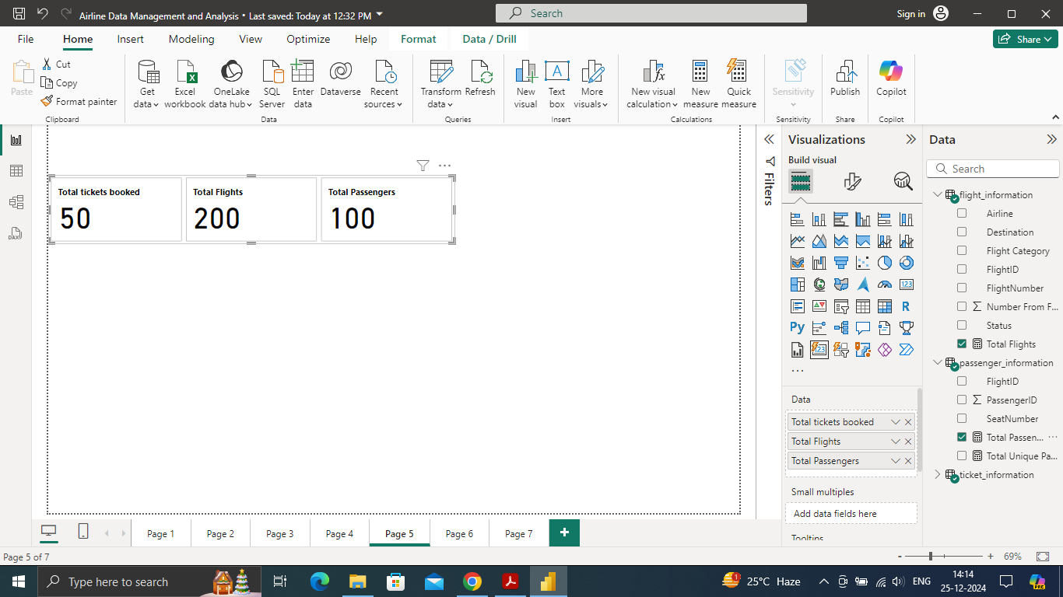

* *Quick views*: For quick view I have created a card visual showing Total tickets booked ,Total Flights, Total Passengers.

**Visual 5 :**

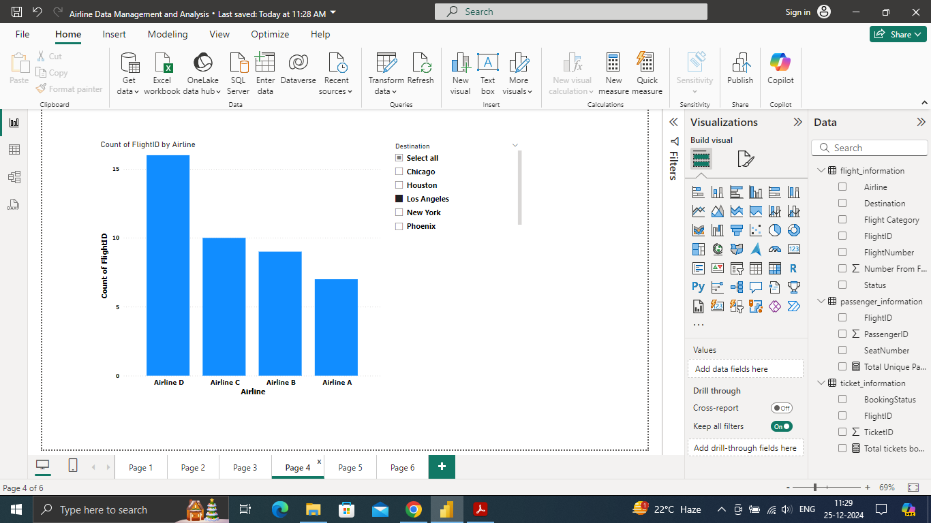

* *Here I have shown flights in different Airlines (by creating bar chart) , then placed the Destination in a slicer* .

**Visual 6:**

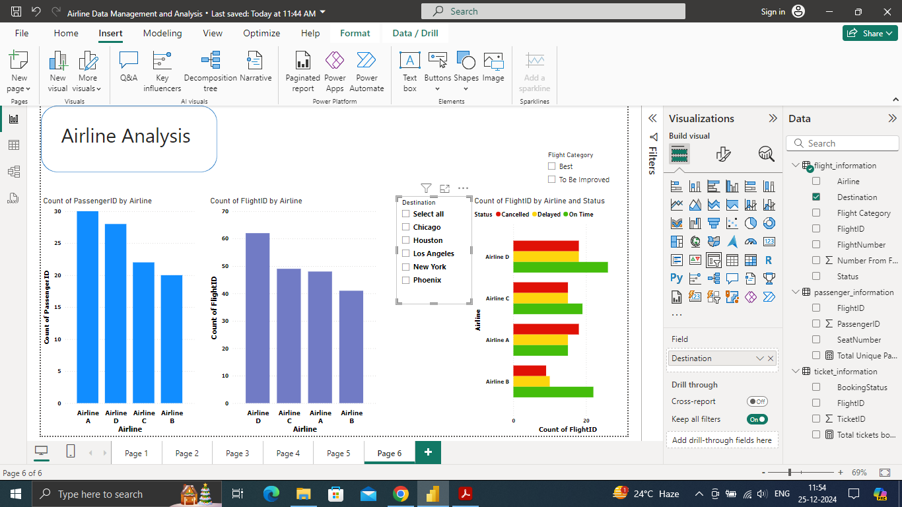

* *Here the task was to create an Airline Specific page so I have displayed some important insights regarding the Airline* .

1. **Task 6 :**

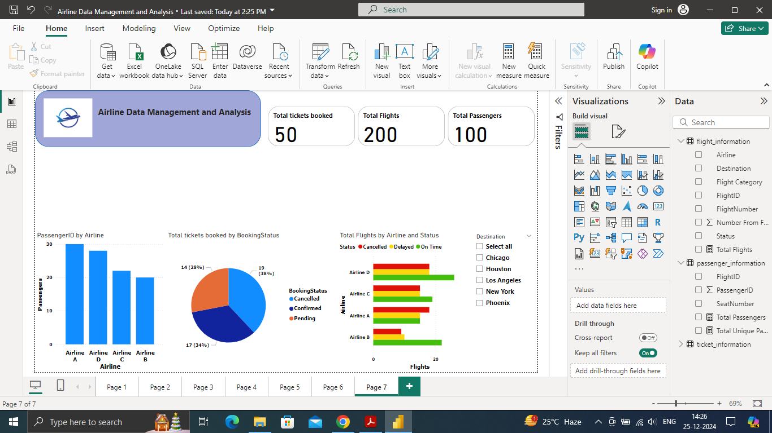

* *The Final Dashboard*
* Here I have shown some insights that was previously created as reports.
* Some valuable insights :
* As we can understand that most of the booked tickets are cancelled.
* Most of the passengers go with the Airline A.
* Also from the stacked bar chart we can understand that Airline D has most of the On Time flights.
* Also the card visual shows Total tickets booked,Total Flight,Total passengers.

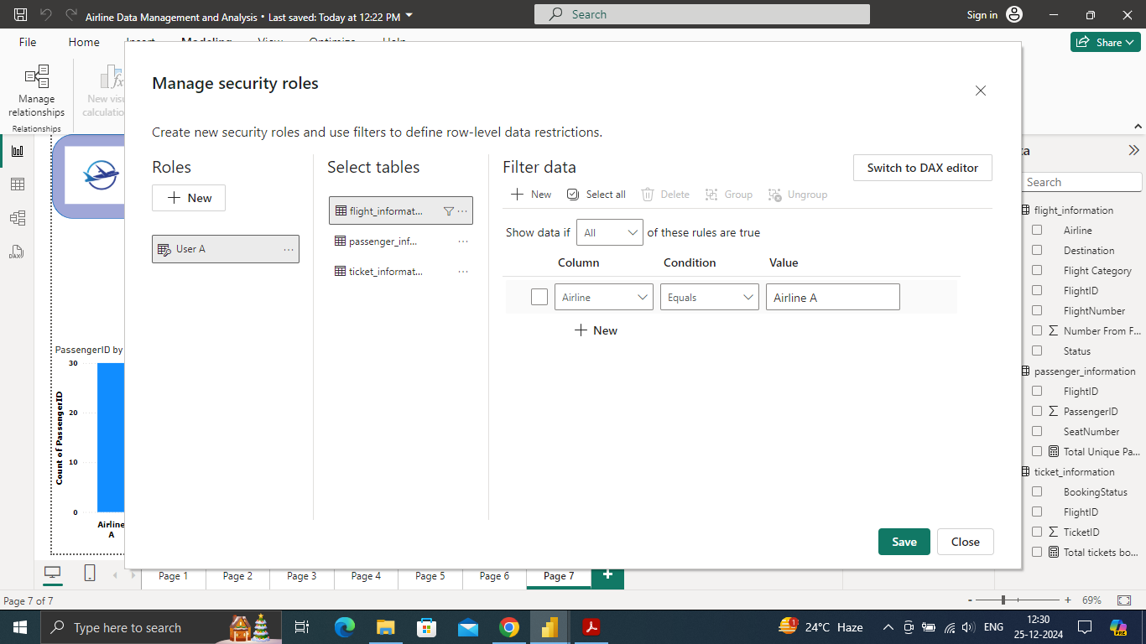

* *Configuration of Row-Level Security (RLS)*
* I assigned the RLS for a certain user that is User A.

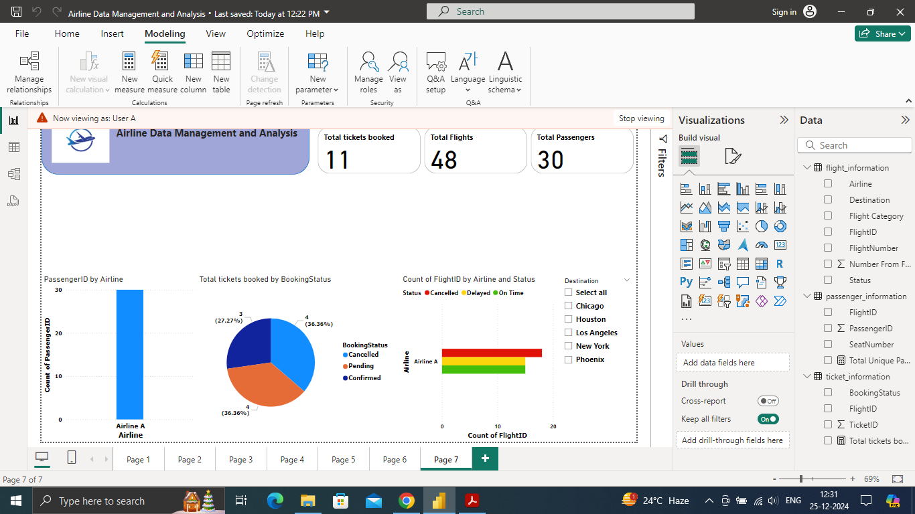

* *After applying the RLS, the view that is generated for User A.*
* Now for the last task : currently I am using the Power Bi Desktop (free version)

so I was not able to access the Schedule Refresh option.